PHYSICOCHEMICAL ASSESSMENT OF HOSPITAL WASTEWATER THROUGH A CLAY MEMBRANE COMPOSITE A CASE STUDY OF GENERAL HOSPITAL MINNA

¹Nyong Imoh Edem, ²Godfred Abang Ofono
Federal Polytechnic Ukana, Ahmadu Bello University Zaria

Correspondent: nyongimoh@gmail.com, 08037100227
ABSTRACT
Hospital wastewater is a complex mixture of chemical, physical, and biological contaminants generated from various healthcare activities, including laboratories, surgical units, pharmacies, diagnostic centers, and patient wards. It contains high concentrations of organic matter, nutrients, suspended solids, pharmaceutical residues, pathogenic microorganisms, and heavy metals, which pose serious environmental and public health risks when discharged untreated into receiving water bodies. Conventional wastewater treatment systems often fail to achieve complete removal of these contaminants due to their complex composition and the persistence of many emerging pollutants. This study investigates the physicochemical characteristics of hospital wastewater and the effectiveness of a clay membrane composite as an adsorption and filtration medium for wastewater treatment. Representative wastewater samples are collected from selected discharge points within the hospital and analysed before and after treatment using standard methods prescribed by the American Public Health Association (APHA). The physicochemical parameters assessed include pH, temperature, electrical conductivity (EC), turbidity, total dissolved solids (TDS), total suspended solids (TSS), dissolved oxygen (DO), biochemical oxygen demand (BOD₅), chemical oxygen demand (COD), nitrate, phosphate, sulphate, chloride, and selected heavy metals such as lead (Pb), cadmium (Cd), chromium (Cr), copper (Cu), zinc (Zn), and iron (Fe). The clay membrane composite is fabricated from selected clay materials and modified with suitable reinforcing materials to enhance its porosity, mechanical strength, adsorption capacity, permeability, and resistance to membrane fouling. The treatment process combines adsorption and membrane filtration, enabling simultaneous removal of suspended particles, dissolved contaminants, and toxic metal ions. The performance of the clay membrane composite is evaluated by comparing the physicochemical properties of untreated and treated wastewater. It is anticipated that the clay membrane composite will substantially reduce turbidity, TDS, TSS, BOD₅, COD, nutrient concentrations, heavy metals, and other pollutants while maintaining pH values within acceptable discharge limits. The treated effluent is subsequently compared with the permissible standards established by the World Health Organization (WHO), the Federal Environmental Protection Agency (FEPA), and the National Environmental Standards and Regulations Enforcement Agency (NESREA) to determine its compliance with environmental discharge regulations. The findings of this study are expected to demonstrate that clay membrane composite technology offers an efficient, low-cost, environmentally friendly, and sustainable approach for hospital wastewater treatment.
Keywords: pharmaceutical contaminants, physicochemical assessment and clay membrane composite.

INTRODUCTION

Hospital wastewater contains a complex mix of pharmaceuticals, pathogens, antibiotic-resistant bacteria, and heavy metals, posing significant environmental and public health risks. Due to the growth in medical services and products during the recent decades, the generation of hospital wastewater (HWW) has been increasing and HWW is of great concern due to its detrimental effects on the environment because of the direct discharge to the natural water bodies (Mahmoudkhani et al., 2012; Meo et al., 2014; Carraro et al., 2016).

Hospital wastewater may include wastewaters from medical tests, blood, urine, feces, gastric fluids, and other body liquids, disinfectants, solvents, acids, bases, reagents, metals, blackwater which includes non-metabolized pharmaceuticals, micro-organisms, and any other medical waste discarded by the hospital (Emmanuel et al., 2002; Jones et al., 2005; Carraro et al., 2016; Pandey and Dwivedi, 2016).
Prior studies show that there are some deficiencies in existing primary treatment plants which are not able to treat HWW unto an optimum standard and it treats wastewater by leaving major contaminants such as pharmaceuticals (Nemathaga et al., 2008; Prayitno et al., 2013; Frederic and Yves, 2014; Tilley et al., 2014; Chanpika et al., 2015; Todt, 2015; Wiest et al., 2018). Moreover, direct discharge of HWW without any treatment is common practice in the developing world (Kumarathilaka et al., 2015). If HWW is left untreated, it may lead to outbreaks of communicable diseases as well as other severe environmental pollution which contributes to increased oxygen demand and nutrient, pharmaceutical loading of water bodies which may result in the promotion of growth of toxic algal blooms, tropical unbalance, destabilized aquatic ecosystem, increasing Viral and Bacterial concentrations which may have acute toxicity (Emmanuel et al., 2002; Aththanyaka et al., 2014) and bioaccumulation of pharmaceuticals in ecosystems (Jean et al., 2012; Zenker et al., 2014; Carraro et al., 2016; Paulus et al., 2019). Hospitals have an important role in the well-being of mankind and other medical research advancements. Different units/services of hospitals require large volume of water according to the activities taking place within the hospitals and generates large amount of wastewater which is an impounding challenge in environmental engineering. Hospital wastewater (HWW) is affected by size (number and type of wards/units), and services provided (kitchen and laundry). The hospital wastes include drugs and their metabolites such as antibiotics, analgesics, antidepressants, organic matters, solvents, metals, disinfectants, specific detergents for endoscopes and other instruments (Kovalova et. al., 2012). These pollutants have adverse toxic effect to humans as well as aquatic animals even at very low concentration and termed as biological active substances.

However, it has been reported that higher levels of suspended solids in the water body can often mean higher concentrations of bacteria, nutrients and heavy metals. In the wastewater which may attach to sediment particles. Even studies have shown that higher levels of suspended solids create hindrances to the proper function of treatment plants (Kumarathilaka et al., 2015). Clay can be used as a coagulant to remove solids in wastewater (Jiang et al., 2004; Hascakir and Deniz, 2008) but available studies specifically on clay as an adsorbent in removing solids in HWW is limited.

Clays are beneficial and successful materials that have been used for the purification of water mainly as an adsorbent to remove contaminants. Clays and their modified composites are either better or equivalent in contaminant adsorption capacity from water (Srinivasan, 2011). Large specific surface area, chemical and mechanical stability, layered structure, high cation exchange capacity (CEC) has made the clays excellent adsorbent materials (Cadena et al., 1990). Thus, clays can be used as a natural adsorbent which also is of low cost.

MATERIAL AND METHODS
Samples of Hospital wastewater were taken from an open drainage channel/stream flowing through Yoruba Road, Minna, Niger State, Nigeria (see Plate II). The location of the sampling point was marked with latitude 9°36′49.06188″ N and longitude 6°32′38.688″ E. The elevation is about 262 yd above mean sea level. The sampling point is defined by the existence of visible municipal waste found in the drainage channel. It implies that the sample is contaminated anthropogenically.
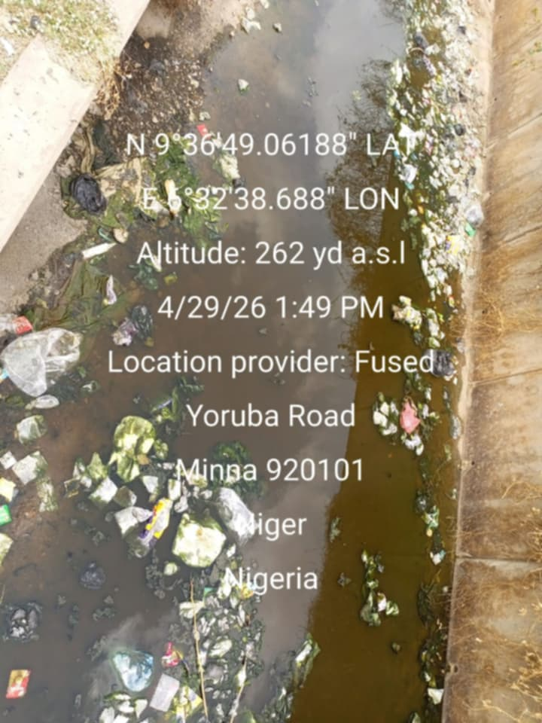
Plate I: Wastewater collection point
3.1 Formation of beneficiated Clay Composite
Two hundred grams (200 g) of raw clay lumps were put in five (5) different 4 Litres of Beakers with 4 Litres of distilled water added. This represents 2.5 % of clay slurry in distilled water. Each Beaker was stirred for 1 hour at 40 revolutions per minute. The clay composite was allowed to swell in distilled water for 22 hrs 57 mins according to Stoke’s Law.
The clay slurries were left to freely settle and the supernatants were collected after the settling time, by decanting them into 1 litre Beaker (Bachiri et al., 2014). The Beaker was covered and allowed to settle and the supernatants were then discarded.
The resultant slurries were thereafter dried in a laboratory oven at a temperature of 105 °C until the water was evaporated and the sample weight became constant. Grinding of the dried samples was done using a laboratory porcelain pestle and mortar. The pulverised clay composite samples were stored in a laboratory sterile 100 ml plastic bottle for characterisation and further studies.
3.2 Clay composite yield
The clay composite yield was calculated using Equation 3.2. few grams of clay composite each was processed to obtain a composite. The Mass of the activated clay composite obtained was measured and the value was substituted in Equation 3.2 to obtain the percentage yield of the clay.
_{𝑌 =} 𝑀𝑎𝑠𝑠 𝑜𝑓 𝑃𝑢𝑟𝑖𝑓𝑖𝑒𝑑 𝐶𝑙𝑎𝑦 𝑃𝑟𝑜𝑑𝑢𝑐𝑒𝑑 _{X 100%} (3.2) 𝑀𝑎𝑠𝑠 𝑜𝑓 𝑅𝑎𝑤 𝐶𝑙𝑎𝑦
3.3 Hospital Wastewater Analyses
Hospital wastewater collected via discharge point was analysed to determine the level of contamination and to know precisely the initial physio–chemical and bacteriological characteristics of the hospital wastewater before treatment.
3.4 pH
The pH of the domestic wastewater was found to be 8.96 which is basic as shown in Table 4.32. The pH value of the domestic wastewater was above the specified permissible value of effluent discharges, irrigation and reuse standards set by the National Environmental Standard and Regulation Enforcement Agency (NESREA) (2011). The pH of the wastewater was basic and the discharge of this domestic wastewater into waterbodies would be detrimental to zooplankton and fishes, thus affecting their physiology.

Table 4.32: Wastewater Quality Analysis
Parameters | Units | Wastewater | NESREA (2011)
Odour | - | Smelling
pH | - | 8.96 | 6.5 -8.5
Turbidity | NTU | 248
EC | µS/cm | 1382
Dissolved Oxygen | mg/L | 1.00 | 4 (Min)
TSS | mg/L | 233 | 0.75
TDS | mg/L | 926
Colour | TCU | 1620
Nitrate | mg/L | 230 | 40
Phosphates | mg/L | 11.8 | 3.5
Ammonium | mg/L | 37.2 | 2.0
Chloride | mg/L | 133 | 350
COD | mg/L | 312 | 30
BOD5 | mg/L | 30.6 | 6
Oil and Grease | mg/L | 10.1 | 0.1
Sodium | mg/L | 29.0 | 120
Potassium | mg/L | 23.0 | 50
Cadmium | mg/L | 0.01 | 0.01
Total Iron | mg/L | 0.83 | 0.5
Lead | mg/L | 0.14 | 0.1
Copper | mg/L | 0.05 | 0.01
Manganese | mg/L | 0.25
Arsenic | mg/L | 0.22 | 0.05
Chromium (Cr⁺⁶) | mg/L | 0.04 | 0.5
Mercury | mg/L | 0.11 | 0.0005
Silver | mg/L | 0.02
Zinc | mg/L | 2.46 | 0.2
Total Coliforms | cfu/100ml | 6.45 x 10³ | 5 x 10³
E. coli | cfu/100ml | 400 | Absent
Faecal Coliforms | cfu/100ml | 640 | Absent
Clostridium perfringens | cfu/100ml | 48 | Absent

3.5 Turbidity
The turbidity of the domestic wastewater as analysed was found to be 248 NTU as shown in Table 4.32. Though, no maximum recommended value for turbidity of wastewater in NESREA, 2011, the turbidity of water for human consumption should not exceed 5 NTU and ideally below 1 NTU when compared with Nigerian Standard for Drinking Water
Quality (NSDWQ) (2015). High turbidity will impact aquatic ecosystems by dispersing sunlight and reducing the oxygen concentration. It also affects photosynthesis as well as the respiration and reproduction of fish. It also harbours microorganisms, and therefore the wastewater requires treatment to get rid of turbidity.

3.6 Oil and grease
The obtained analytical result for oil and grease was 10.1mg/L which was far above the 0.1 mg/L maximum permissible limit specified by NESREA (2011). Oil and grease include fats, oils, waxes, and other related constituents found in wastewater. Fats and oils are regularly used in the preparation of food, with residual cooking oil, margarine and butter. These fats and oils collect inside the sewers and over time, harden to a concrete like material and restrict the flow of wastewater in the pipes.
3.7 Heavy Metals
The obtained analytical results for the iron, cadmium, lead, copper, manganese, arsenic, mercury silver and zinc were found to be 0.83 mg/L, 0.05 mg/L, 0.14 mg/L, 0.05 mg/L, 0.25 mg/L, 0.22 mg/L, 0.11 mg/L, 0.02 mg/L and 2.46 mg/L These listed values were far above the maximum permissible limit set by NESREA (2011). The ability of a waterbody to support aquatic life, as well as its suitability for other uses depends on many trace elements. Some metals, such as manganese, zinc and copper, when present in trace concentrations are important for the physiological functions of living tissue and regulate many biochemical processes. The same metals, however, discharged into natural waters at increased concentrations in sewage, can have severe toxicological effects on humans and the aquatic ecosystem (NWQRL, 2021).
3.8 Indicator Organisms
The obtained analytical results for total coliforms, faecal coliforms, Clostridium perfringens and E. coli were found to be 6450 cfu/100 mL, 640 cfu/100 mL, 48 cfu/100 mL and 400 cfu/100 mL respectively. The water pollution caused by faecal contamination is a serious problem due to the potential for contracting diseases from pathogens. Coliforms such as E. coli come from the same sources as pathogenic organisms. These indicator organisms are required to be removed from the wastewater before it is discharged to the rivers.

RESULT AND DISCUSSION
In this section, the pollutants in the hospital wastewater were reduced to an acceptable level by the beneficiary clay composite adsorbents before discharging into the receiving water bodies. The effect of contact time, temperature and dosage on the produced clay composite adsorbents to remove the pollutants from hospital wastewater collected via sewer were tested and the results are presented in this section.
    - Effect of contact time on heavy metals removal
The effect of contact time on the adsorption of iron, lead, copper, manganese, arsenic, mercury silver and zinc onto clay composite adsorbents was studied at a contact time of 10, 20, 30, 40, 50 and 60 minutes using an adsorbent dosage of 25 g/100 mL of wastewater at a temperature of 29.5
°C and pH of 6.9.
It was observed that an increase in the fraction of the heavy metals adsorbed occurred with a corresponding increase in the contact time. The effects of contact time on the adsorption of these selected heavy metals onto the adsorbents are important to achieve equilibrium adsorption.
The percentage removal of iron, lead, copper, manganese, arsenic, mercury silver and zinc after treatments with clay composite adsorbents at various contact times are presented in Figures 4.1 (a – d), the rates of adsorption were faster initially but became slow on reaching the equilibrium. Different equilibrium times were observed for all the parameters on the adsorbents. Rapid adsorption rates were obtained between the contact time of 10 – 40 minutes. The increase in contact time from 10 minutes gradually reduced
the heavy metal contaminants to 50 minutes contact time. On reaching the equilibrium adsorption, the rate of adsorption equals the rate of desorption; therefore, slow uptake of pollutants was observed from 40 minutes upward. The slow uptake and the slight or no decrease in percentage removal with a further increase in contact time might be due to saturation of the surface area of the adsorbent with heavy metal pollutants.

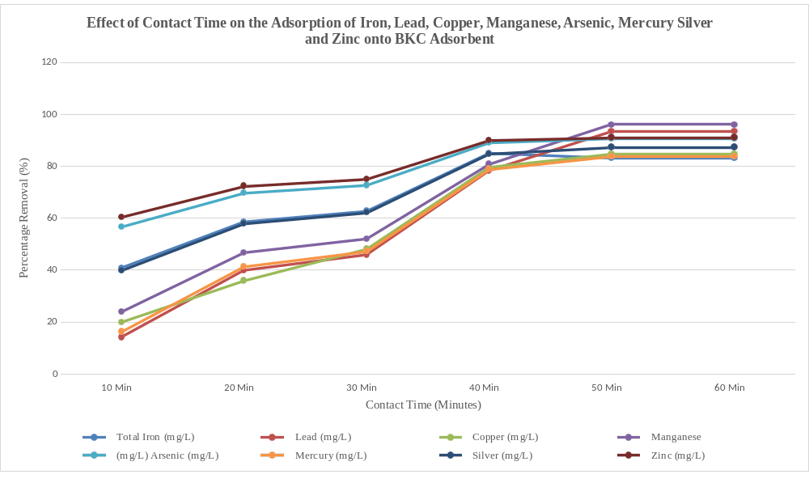

Figure 4.1 (a): Effect of Contact Time on the Removal of Iron, Lead, Copper, Manganese, Arsenic, Mercury Silver Adsorbent

    - Effect of contact time on nutrients, COD, BOD and oil and grease removal The effect of contact time on the adsorption of nitrate, phosphate, ammonium, COD, BOD and oil and grease onto BC composites adsorbents was studied at contact time of 10, 20, 30, 40, 50 and 60 minutes using an adsorbent dosage of 25 g/100 ml of wastewater at a temperature of 29.5 °C and pH of 6.9.
The rate of adsorption equals the rate of desorption on reaching the equilibrium, therefore slow or no uptake of nitrate, phosphate, ammonium, COD, BOD, oil and grease was observed. The slow uptake and the no increase in percentage removal with a further increase in contact time were due to saturation of the surface of the adsorbent with pollutants.
The percentage removal of nitrate, phosphate, ammonium, COD, BOD and oil and grease after treatment with BKC composites adsorbents at various contact times were presented in Figure 4.2 (a – d).

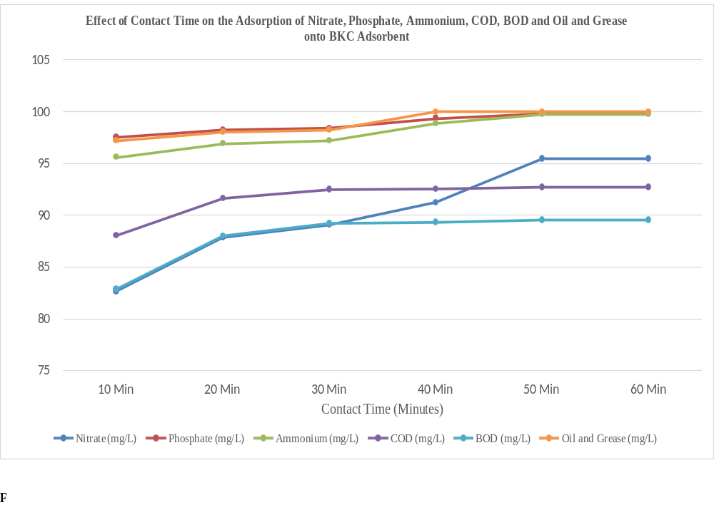
Figure 4.2 (a): Effect of Contact Time on the Removal of Nitrate, Phosphate, Ammonium, COD, BOD and Oil and Grease by BCK
Figure 4.3 (b): Effect of Contact Time on Turbidity, Suspended Solid, Colour, Dissolved Oxygen and EC
It was revealed that an increase in the reduction of turbidity, suspended solids, colour, EC and improvement in pH and dissolved oxygen occurred with a corresponding increase in the contact time until equilibrium adsorption was achieved. The percentage removal of turbidity, suspended solids, colour, EC and improvement in pH and dissolved oxygen values at various contact times were attached as presented in Figures 4.3(a – e).
It was also observed that rapid percentage removal was obtained between the contact times of 10 – 20 minutes for the physical parameters. However, the contact time has no significant effect on turbidity, suspended solid, colour, or EC removal from 30 minutes upward as presented in Figure 4.3 (a –e). The slight increase in the removal of turbidity, suspended solids, colour, and EC with a further increase in contact time was due to saturation of the surface area of the adsorbent with pollutants.
CONCLUSION AND RECOMMENDATION
1.01 CONCLUSION
This study assessed the physicochemical characteristics of hospital wastewater from General Hospital Minna and investigated the potential of a clay membrane composite for wastewater treatment. The study was based on the recognition that hospital wastewater contains complex mixture of organic and inorganic pollutants that may pose environmental and public health risks if discharged without adequate treatment.
The physicochemical assessment of the wastewater showed that the quality of the untreated hospital wastewater varied considerably across the parameters investigated. Parameters such as pH, biochemical oxygen demand (COD), and selected heavy metals provided an indication of the level of organic and inorganic pollution present in the wastewater. The observed characteristic demonstrates the need for appropriate treatment before the wastewater is discharged into the environment.
The study therefore concludes that the use of a clay membrane composite can contribute to the reduction of physicochemical pollutants in hospital wastewater and represents a promising alternative or complementary treatment technology for hospitals, particularly where conventional treatment systems are expensive or difficult to maintain.

1.02 RECOMMENDATION
Adoption of appropriate treatment systems: General Hospital Minna should ensure that its wastewater undergoes adequate treatment undergoes adequate treatment before discharge into the environment. Clay-based membrane technology may be considered as part of an integrated treatment system.
- Monitoring of wastewater quality: Regular monitoring of hospital wastewater should be carried out for parameters including pH, BOD, COD, turbidity, total suspended solids, electrical conductivity and heavy metals to determine changes in wastewater quality over time.
- Heavy-metal and emerging-contaminant assessment: Future studies should investigate a wader range of heavy metals, pharmaceutical residues, antibiotics, and other emerging contaminants commonly associated with hospital wastewater.
- Combination with other treatment processes: Clay membrane treatment should be investigated in combination with other treatment processes such as adsorption, coagulation, biological treatment, or advanced oxidation processes to improve overall pollutant removal.

REFERENCES
Atthanyaka K.,Pathmarajah,S.,& Premasiri,H.M(2014). Estimation of infiltration rate using Horton’s equation in different land uses in the Mahaweli river basin.Tropical Agricultural Reseach,-25_(3) 345-354.
Bachiri, E. M., Akichouh E., Miz, H., Salhi, S., & Tahani, A. (2014). Adsorptions desorptionand kinetics studies of Methylene Blue Dye on Na-bentonite from Aqueous Solution. Journal of Applied Chemistry, 7(7), 60-78.

Carraro, E., Breschigliaro, S., &Musiani, M. (2016). Hospital wastewater treatment: A review of the current situation and the potential application of membrane bioreactors. Environmental Science and Pollution Research, 23(1), 331-346. doi: 10.1007/s11356-015-5374-5
Chanpika, p., Babel, M. S., & Tripathi, N. K. (2015). Spatial assessment of infiltration rate using Horton’s model in Chi River Basin, Thailand. Journal of Hydrology and Meteorology, - 12- (1), 45- 45 – 54. doi.org
Emmanuel, E,.Pierre,S.,& Perrodin,Y., (2022).Groundwater contamination by stormwater.A threat to middle-sized cities in France.Water Reseach,_36(4),878887.doi.org
Frederic, F., & Yves, G. (2014). Impact of land use change on soil infiltration capacity in West Africa Catena, 121, 85-94, doi.org
Hascakr, V., Deniz, A. (2008). Estimation of infiltration rates using double ring infiltrometer and modeling with Horton’s equation. Journal of Applied Sciences, -8-(6), 1124-1128.
Jean, J. S,.Liu,.C. C., & Lee, M. K. (2012). Infiltration characteristic and groundwater recharge potential in urban areas. Environmental Geology, - 61 –(8), 1423-1432. doi.org
Jone, J. A., Creed, I. F., Hatcher, K. L. Warren, R. J., & Adams, M.B. (2005). Ecosystem regulate stremflow response to forest hearvest at eight northern hemisphere watersheds. Hydrological Processes, - 19 – (18) 3511- 3530, doi. Org
Kovalova, L., Siegrist, H., Singer, H., Wittmer, A., & McArdell, C. S. (2012) Hospital wastewater treatment by membrance bioreactor: Performance and efficiency for organic micropollutant elimination. Environmental Science & Technology, - 46 – (3), 1536-1545.doi.org
Mahmoud Kahani, S., Ghahraman, B., & Davary, K. (2012). Evaluation of infiltration models in arid and semi-arid regions of iran. Journal of Agricultural Science and Technology, - 14 – (5), 987- 998.
Meo, S. A., Al-Dress, A. M., Almasri, A. A., & Al-Harbi, T. M. (2014). Effect of heat exposure on infiltration rate and soil properties. European Review for Medical and Pharmacological Sciences, -18-(16), 2345-2351. doi.org
Nemarthaga, A., Patel, J., & Reddy, K. S. (2015). Infiltration characteristics of soils under different land uses. International Journal of Agricultural Science, -7-(2), 112 - 118
Pandey, A., & Dwivedi, S. B. (2016). Estimation of infiltration rate using Horton’s model for Varanasi region. Journal of soil and water conservation, - 15- (3), 245-250.
Prayitno, J., Sudarmadji, S., & Haryono, E. (2013). Analysis of infiltration capacity using Horton’s method in karst area of Gunung Kidul, Indonesia. Indonesian Journal of Geography, 45-(2), 89-98.

Tilley, E., Ulrich, L., Luthi, C., Reymond, P., & Zurbugg, C. (2014). Compendium of sanitation systems and technologies (2nd ed.). Swiss Federal institute of Aquatic Science and Technology.

Srinivasan., V., Lambin, E. F., Gorelick, S. M., Thompson, B. H., & Rozelle, S. (2011). The nature and causes of the global water crisis: Syndromes from a meta-analysis of coupled human-water studies. Water Resources Research, - 47 – (2), W00A12. Dio.org

Wiest, L., Baudot, R., Lafay, F., Lafolie, F., & Vulliet, E. (2018). The challenge of estimating infiltration of emerging contaminants in soil. Science of the Total Environment, 644. 140-149. doi.org
Zenker, A., Cicero- Fernandez, M. R., Castano, A., & Salgado, R. (2014). Removal of pharmaceuticals in wastewater treatment plants and environmental risk assessment. Science of the Total Environment, 466, 140-147. doi. org

